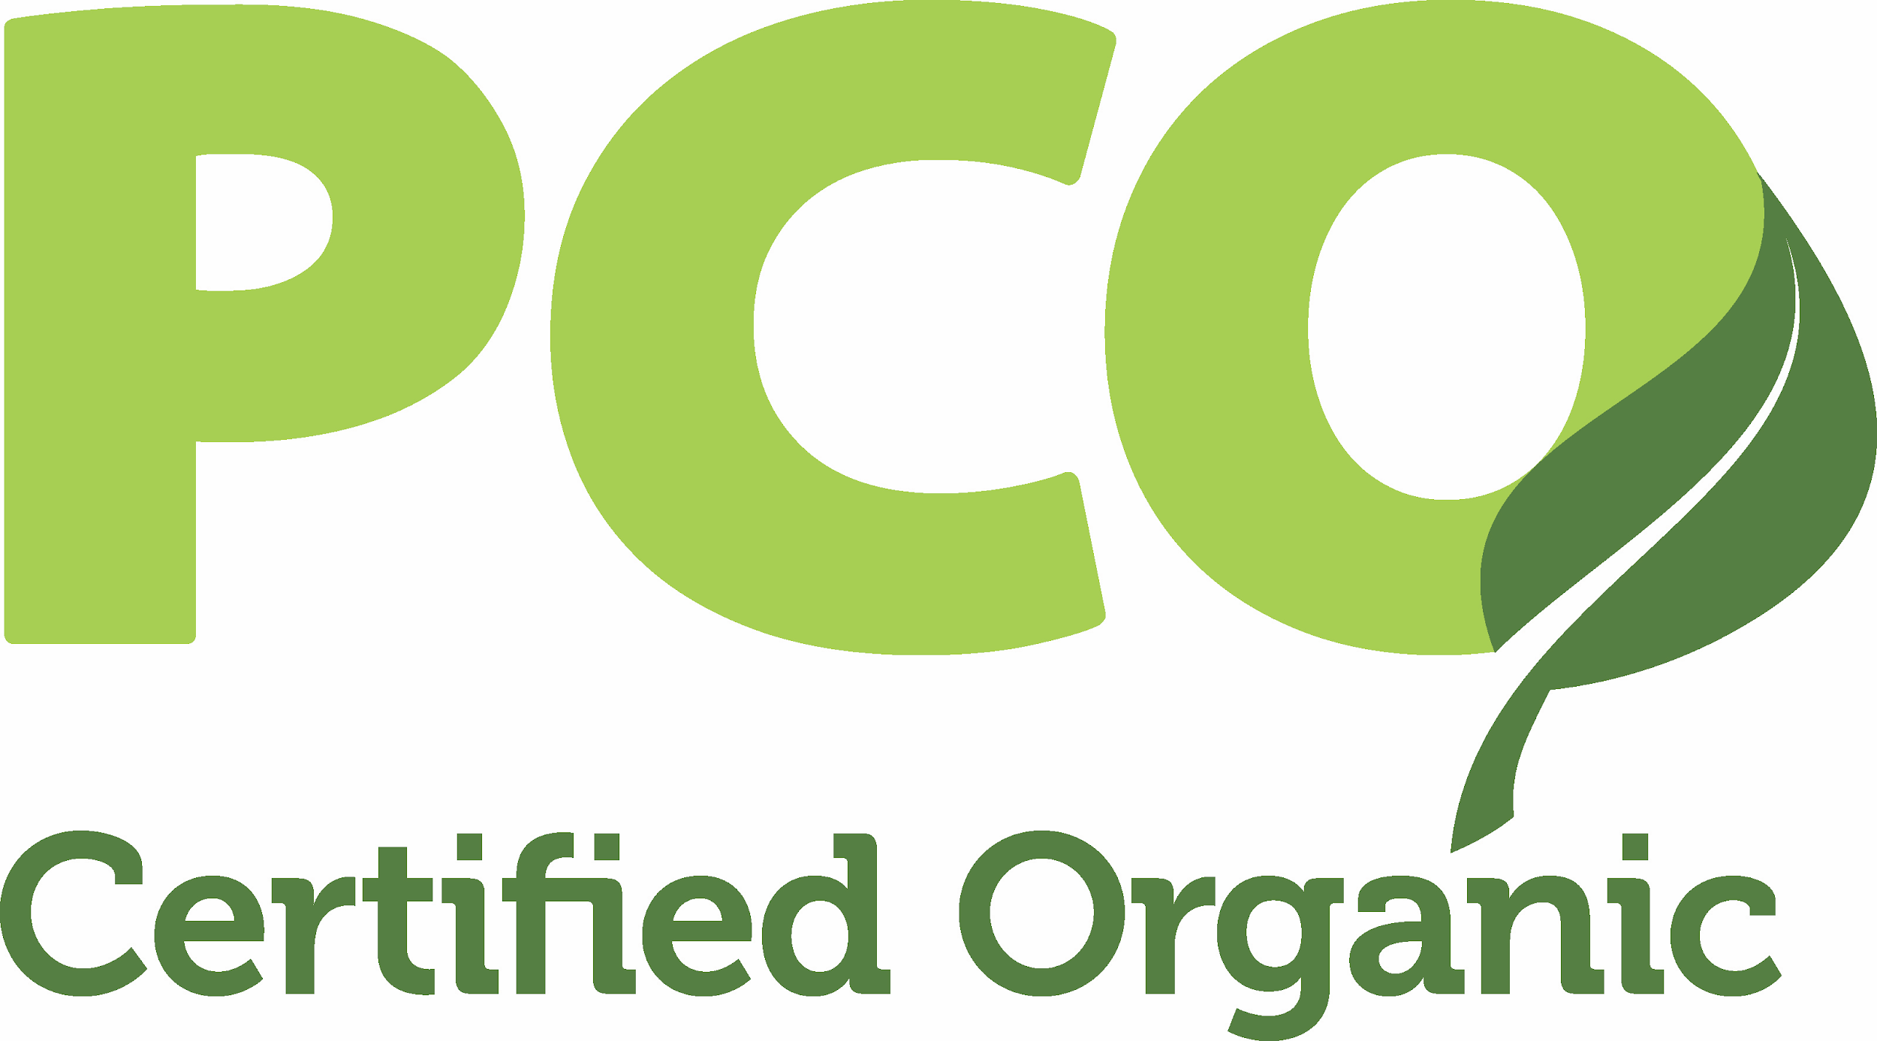

FOR IMMEDIATE RELEASE

7TH ANNUAL ORGANIC FARMFEST CELEBRATES FAMILY FARMS
Policy Forum focuses on grassroots efforts to save, strengthen rural economies

CENTRE HALL, P.A. (July 18, 2018) -- Phenomenal growth in organic farming over the past few years has launched Pennsylvania into the Number 2 ranking in organic sales, second only to California. Pennsylvania Certified Organic (PCO) will celebrate this achievement by presenting the 7th Annual PA Organic FarmFest, July 28, 2018, at Grange Park, Centre Hall, PA. The day-long event will run 9am - 6pm, is free and open to the public.

Growth often brings with it challenges. Pennsylvania Food & Farm Policy Forum, presented at FarmFest, will provide an opportunity for attendees to learn about, share and discuss regional issues and engage with public officials on important topics affecting Pennsylvania’s agricultural community.

“This year has been politically tumultuous with many new issues affecting farmers in addition to the controversies surrounding passage of the Farm Bill,” comments Leslie Zuck, Executive Director of PCO, “No one knows what lies ahead but what we do know is that farmers, as well as the general public, want to be better informed and want their voices to be heard.”

To address this need, PCO has partnered with Pennsylvania Farmers Union, Pennsylvania Association for Sustainable Agriculture (PASA) and Rodale Institute to present speakers, panels and discussion circles on the Farm Bill, PA Dairy Economic Issues, Grassroots Advocacy, Women in Politics, Transitioning to Organic, Animal Welfare Standards and more.

Featured speakers and panelists include:

Rob Larew, Senior Policy Advisor, National Farmers Union
Russell Redding, Secretary, Pennsylvania Department of Agriculture
Hannah Smith-Brubaker, Executive Director, PASA
Glenn “GT” Thompson, U.S. Representative
Kristina Watson, Director, Federal Government Affairs, Pennsylvania Farm Bureau
Detailed agenda is available at: https://farmfest.paorganic.org/farmpolicyforum/

Educational workshops, demos abound

Workshops:
For the Love of Pollinators
Holistic Animal Care for Pets and Livestock
Unusual Edible Perennials: How to Grow and Use Them
Healthy Soil, Healthy Humans
Let Them Eat Sewage Sludge: What Goes in Your Food and Water

Ongoing demonstrations and activities: Blacksmithing, wild mustangs, rescued farm animals, wildlife, falconry, reptiles, fish printing, wagon rides, bike taxis, camping demos, organic pavilion

FarmFest is all about families

With 100 exhibitors, barns full of animals, health and environment workshops, craft demonstrations, organic food and live entertainment, FarmFest visitors will find much of interest to all ages. Camping is available onsite and dogs and bicycles are welcome.
(Rain or Shine, Zero waste )

Be a part of it!

Businesses or organizations that wish to participate as a vendor, exhibitor or sponsor may sign up online through Thursday, July 26, 2018, or by calling 814-422-3001, https://farmfest.paorganic.org/sponsors-vendors/

PCO is a non-profit organization based in Spring Mills, Pennsylvania, that educates and certifies more than 1,500 organic farms and processors. For information on organic certification, contact PCO at www.paorganic.org, 814-422-0251.

For more information on FarmFest or the Food & Farm Policy Forum, please contact:

PCO
106 School St., Suite 201
Spring Mills, PA 16875
farmfest@paorganic.org
Media Requests: 814-422-0251 (April Kocis, Outreach Specialist)
Vendor Inquiries: 814-422-3001 (Jim Pierce, FarmFest Coordinator)
Sponsorship Inquiries: 814-404-6567 (Leslie Zuck, Executive Director)

