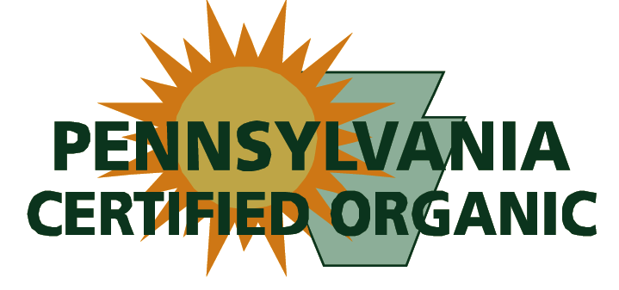
106 School Street, Suite 201, Spring Mills, PA 16875
(814) 422-0251 • fax (814) 422-0255
pco@paorganic.org, www.paorganic.org

August 18, 2014

Contact: Lee Rinehart, lee@paorganic.org

For Immediate Release:

Spiral Path offers Field Day on Ecological Vegetable Farming

Spiral Path Farm, a PCO-certified organic farm, in partnership with Rodale, the Pennsylvania Association for Sustainable Agriculture (PASA), Pennsylvania Certified Organic (PCO), and Penn State College of Agricultural Sciences announce a field day at Mike and Terra Brownback’s Spiral Path Farm on September 4, 2014 from 10am-3pm. We would like to thank the following sponsors: Bejo Seeds, Family Farm Insurance, The Fertrell Company, IFCO, Natural Resources Conservation Service (NRCS), Seedway, and Zeiset Ag. Sponsorships are still available and those interested should contact Lauren Smith at PASA. lauren@pasafarming.org.

The field day will include a seed trial featuring tomato, pepper and brassica varieties grown under organic conditions and will focus on improving soil quality and plant health while maintaining high crop production. Learn Spiral Path’s cover crop interseeding techniques for planting into growing crops, and planting and cultivating techniques for dealing with difficult weeds such as hairy galinsoga.

Join Rodale’s Rick Karr for a discussion of on-farm non-animal manure composting and vermicomposting and Dr. Kris Nichols for an in-depth look at microbiology in soils and compost. Learn about biological controls from Steve Bogash and Tom Ford of Penn State Extension, and Mike Brownback, along with representatives of the Penn State Entomology Department, will discuss pest control techniques including intentional planting of host plants such as marigolds and Alyssum to provide habitat for naturally occurring predator insects. Dave Mortenson, Penn State Professor of Weed and Applied Plant Ecology, will be on site to set the tone for the field day focus us on the ecological aspects of organic farming.

The field day will be held at Spiral Path Farm, 538 Spiral Path Lane, Loysville PA. From 322 take Port Royal exit then Rt. 75. Turn left onto 74S, then turn right onto 17W. Turn left onto 850E in Kistler, go 2 miles and turn right onto the Emory Green Road. Spiral Path Lane is in 9/10 mi.

The $25 registration includes lunch, and participants can register online at http://www.paorganic.org/education/spiral-path-farm-field-day or by calling Lee Rinehart at 814-470-9734.

